Approach – 4 Template Registration + Relative Co-ordinates + Multi Scan Zonal OCR + Validation

This approach is completely designed by me. The root of this idea is Figma where I had an experience with wireframe and template -> individual elements.
The techniques are to be chosen based on the results in trial and error.

Template Canonicalization (Creation) - Create a perfect master version of the claim form.
If multiple versions exist:
Create separate versions
Maintain template library
Match inputs to correct templates.

Template Registration (Alignment) – Align incoming documents to canonical template.
This ensures bounding boxes work regardless of:
Slight rotation
Scaling
Minor shifting
Techniques:
Option A: Feature-based alignment
- ORB / SIFT keypoints
- Match features
- Estimate homography
Option B: Structural alignment
- Detect major grid lines
- Match grid intersections
Option C (Research-grade): ECC (Enhanced Correlation Coefficient)
- Optimizes image alignment globally
The incoming documents are warped into same coordinates as template.
If alignment confidence is low:
- Reject document
- Request manual review
- OR fallback to full-page OCR + LLM

Relative Coordinate Mapping - Storing the co ordinates with respect to the document dimensions. This is done to maintain the position even when the document is resized (scaled).

Zonal Cropping – Crop each field where each becomes a mini document.
If region seems blank:
- Slightly expand bounding box
- Try multi-crop margins
- Run alternate preprocessing

Zone based Pre Processing – Different Field needs different preprocessing. Numeric Fields, Alphanumeric, Checkboxes etc are to be processed differently.
Maintain multiple preprocessing presets per zone.
Select best based on OCR confidence.
Zonal OCR (Specific Registration)
Pre-Defined Regex and Possible Representations.
Techniques
- Whitelisting characters
- Different PSM modes
- Multiple scaling attempts

Regex + Semantic Validation

Cross-Field Logical Validation – Eg. Charged Amount and Billed Amount Equality. Date of Service can’t be in future.

Optional LLM Reconciliation

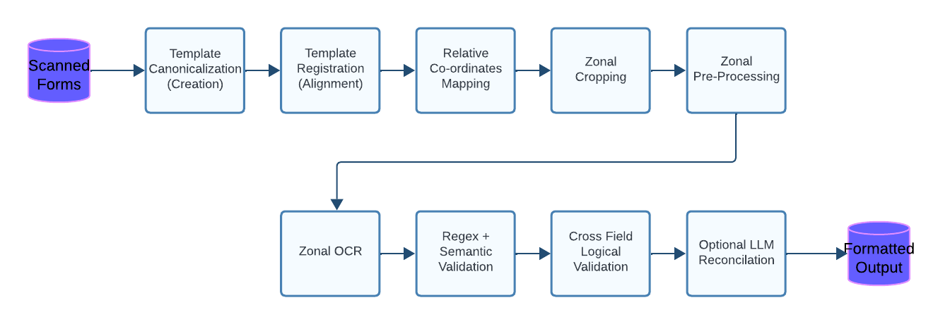

Template Canonicalization – Master Template
Truth Coordinate system. Every incoming form will be warped into this canonical template.
Step 1: Create the template – Select highest quality master copy.
Step 2: Preprocess Only for Structure.
Step 3: Detect Structural Anchors. Anchors are fixed elements that never changes its position.
A. Corner-Based
Use Harris / Shi-Tomasi corner detection to find strong intersection points.
B. Feature-Based (More Robust)
Use: ORB (Oriented FAST and Rotated BRIEF) to track key points in the image, SIFT, AKAZE
These generate invariant keypoints.
Step 4: Define Canonical Coordinate Space
Choose:
- Fixed resolution (e.g., 2480 x 3508 for A4 @ 300 DPI)
- Define origin at top-left
Step 5: Store as Metadata (Very Important)
Your canonical template should store:
- Anchor keypoints descriptors
- Template image
- Field bounding boxes
- Field type (numeric, text, date, alphanumeric)
- Expected regex pattern
- Expected length range
- Field priority level
Output
One fixed template image
Anchor descriptors for alignment
Fixed coordinate grid
Field zone definitions
Validation rules attached to each field

Descriptors encode:
- Edge patterns
- Corner gradients
- Local structure around each keypoint

